BEETHEFIRST 3D printer Integration Documentation

Date | Version | Author | Description
28/04/2015 | 6 | MG | Insert new workflow for Prepare Print Procedure  Added Workflow Images  Open Office documentation file  Created GitHub repository https://github.com/beeverycreative/BEETHEFIRST-Integration
21/04/2015 | 5 | MG | Updated Workflow Documentation for maintenance App (Nozzle maintenance tasks)  Updated and Translated Gcode Table  Updated Documentation workflows and instructions
17/04/2015 | 4 | JP e MG | Added documentation for BEETHEFIRST maintenance operations
09/04/2015 | 3 | MG | Transfer File Documentation
23/03/2015 | 2 | MG
13/03/2015 | 1 | JP | Initial version

Introduction

The current document is intended to describe the main features of the BEETHEFIRST hardware and its most important procedures, namely:
- Printer boot process;
- Firmware updates;
- Calibration;
- Filament change;
- Other print procedures.

The Printer

The BEETHEFIRST is a 3D Cartesian 3D printer that uses a Fused Filament Fabrication process to create parts. The printer uses GCode and MCode commands to define its actions. A list of supported commands is specified in the section "BEETHEFIRST USB Descriptor"
The main features of the BEETHEFIRST are:
- Cartesian 3D printer with a 190x135x125mm build volume;
- 32bit ARM microcontroller electronics.

A USB connection is used to interface the printer. During normal operation the printer never takes the initiative to communicate with the host computer. In order to retrieve information from the printer, the host computer must send a command to which the printer replies with an answer.

The printer is controlled by a 32bit ARM microcontroller. Its memory is divided into 3 zones:
- Bootloader;
- Firmware;
- Configurations.

USB Connection

All the interaction with the printer is done through a USB connection. This connection is used for the following tasks:
- Send GCode and MCode commands
- Firmware updates
- File transfer

The printer USB device has a vendor ID 0x29c9 and a product ID 0x0001. For the complete device descriptor information please read the attached document in "BEETHEFIRST USB Descriptor".

Bootloader

The bootloader is loaded during the printer startup. Its main function is to manage and launch the printer firmware. The bootloader actions are triggered by GCODE commands sent by the host computer through a USB connection. The source can be found in the repository https://github.com/beeverycreative/BEETHEFIRST-bootloader.
At the end of every command sent to the printer must be a new line character. The printer will always reply to any command sent with a new line character. If the command sent by to the printer is unknown the printer will reply with an "ok Bad M-code ", otherwise the printer will return "ok" followed by the command response.
For example, the "G28" command (Home all axis), a command which only available in the printer firmware, will return "ok Bad M-code ".
In turn, the command "M116" (report bootloader version), will get response similar to "ok 4.0.0"
In order to boot the printer to firmware a "M630" command must be sent to the bootloader.
All GCode and MCode commands are implemented in the source file "gcode_process.c" and are listed in the "GCode Commands".

Firmware

The printer firmware is responsible for all operations related to the printer operations, like movements and settings. Like the bootloader, the firmware responds to every command ended with a "new line" character. The printer replay message has the following structure:
<Command response> ok Q:<Commands Waiting>
The <Command response> field has the information regarding the sent command and the <Commands Waiting> field reports how many commands are in the queue waiting to be executed.
During its normal operation the printer firmware can have different states. The state of the printer can be verified by sending the "M625" command. The table below lists the possible states and the typical command response:
State | Command Response
Ready | S:3 ok Q:0
Moving | S:4 ok Q:0
Printing | S:5 ok Q:0
Pause | S:7 ok Q:0
Shutdown | S:9 ok Q:0

The firmware source code can be found in the repository https://github.com/beeverycreative/BEETHEFIRST-firmware. The GCode and MCode implementation can be found in the "gcode_process.c" file.
A list of the GCode and MCode implemented by the firmware can be found in section "GCode Commands".

Configurations

Like the bootloader and the firmware, the configurations zone is a reserved space in the internal memory. This zone can be accessed by both bootloader and firmware to store and read essential configurations to the printer operation. Some examples of these configurations are.
- Axis steps per mm;
- Axis maximum feed rates;
- Calibration configurations;
- Other machine specific configurations;
The configurations can be consulted by sending the "M600" command.

Printer Procedures

As referred before, there are some procedures that must be implemented in order to operate the printer or to guide the user in some maintenance tasks. In the current section we'll be describing each of these procedures.
A procedure is composed by a group of commands and actions.

Printer startup

Once we connect the printer to the computer, the first thing we must do is to verify if the printer is running the latest firmware, and if it does not we should use the bootloader to flash the newer version (7.0.2 as of this writing).
To do that we must verify if the printer is in bootloader mode, if not we must reset the printer into bootloader. Once the printer is in Bootloader, it can update the firmware following the flashing firmware procedure.
By sending a "M609" the printer is restarted in Bootloader. Some old firmware do not have this command implemented. In this cases the user must shutdown the printer so it can start in Bootloader.
Below is a diagram that describe the steps to successfully boot the printer.
As a first step towards creating a connection with the BEETHEFIRST printer, we must implement the green and blue sequences. This are the mandatory sequences to start controlling the printer. The dot sequences should be applied in a second phase to implement firmware updates features.

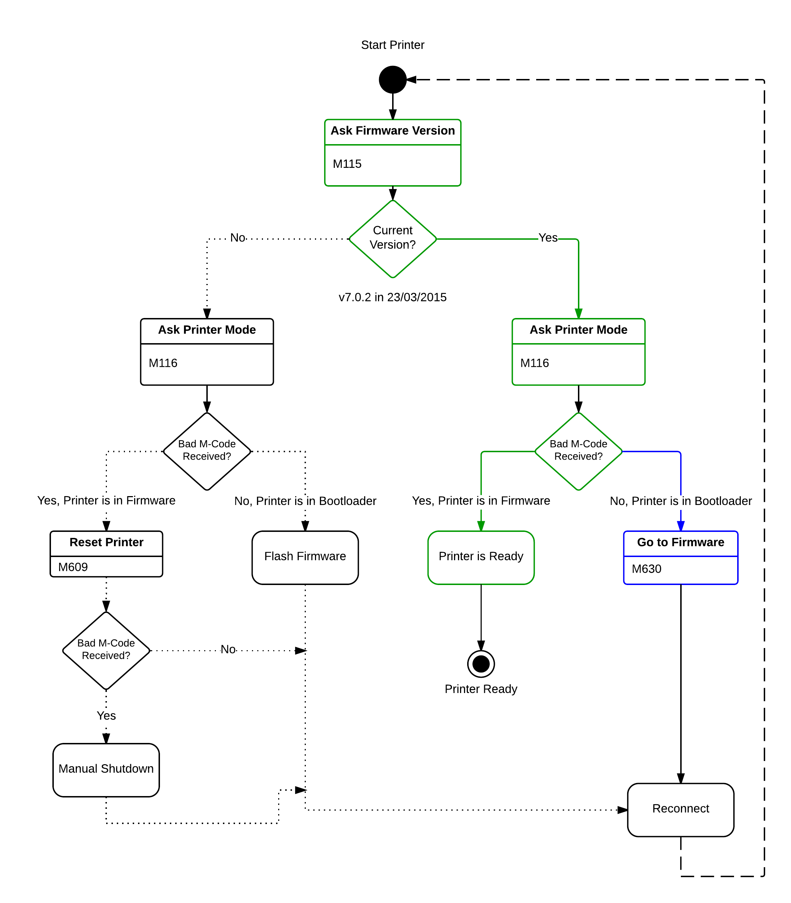

Flash new Firmware

As stated before, the BEETHEFIRST 3D printer supports firmware update. This procedure is required when a new version is available and it is not needed to operate the printer. The BEETHEFIRST firmware is publicly available at the repository https://github.com/beeverycreative/BEETHEFIRST-firmware
To flash the BEETHEFIRST firmware it is necessary to have access to the correct firmware available inside the BEESOFT installation directory, or compile from the source repository.
As a good practice, before starting to transfer the firmware binary file the firmware version stored by the bootloader should be defined to “0.0.0”. This is done by sending the command:
M114 A0.0.0
To start the transfer it is necessary to send a M650 command. This command set the printer in transfer mode and passes the number or bytes to be written. This is done by sending the command:
M650 A”FILESIZE”
After starting the transfer, the firmware file should be transferred to the printer in packets of 64 bytes of binary data. After receiving a packet, the printer will return the data received to the computer. The software should compare these to identify transmission errors. Firmware transfer failure is a separated procedure and should be addressed later.
At the end of a successfully firmware transfer, the software should set the new firmware version by sending the command:
M114 A”FW.Version”
NOTE: Some USB libraries, like pyusb, may require a small delay after a package transmission to work properly. A micro second relay revealed to work with PyUSB.

Bellow is a workflow of the firmware update procedure:
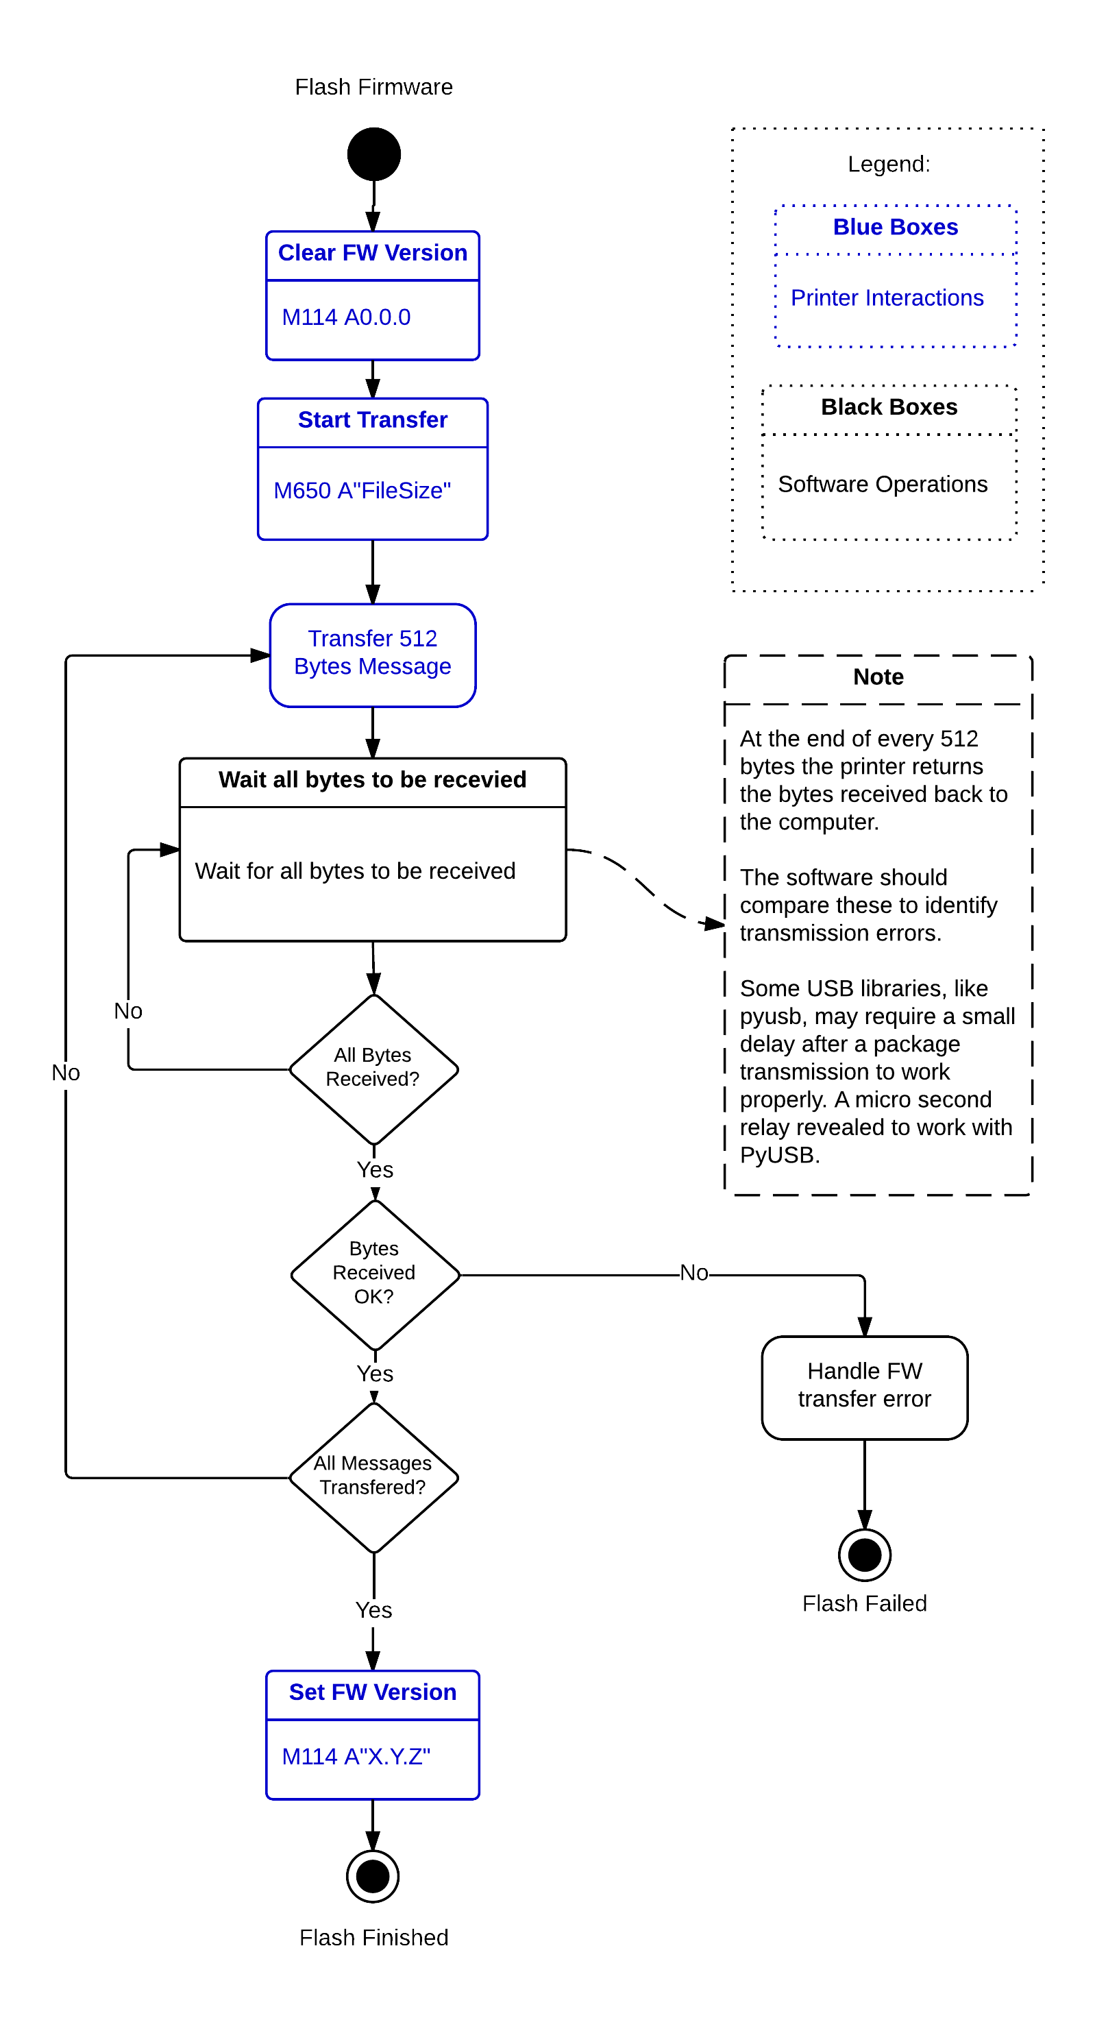

Print GCode File

A typical print procedure has 3 main tasks:
- Transfer the GCode file to the printer internal memory
- Prepare the printer for the printing process
- Verify printing state

The first 2 tasks will be will be detailed in their specific sections in this document.

The diagram in the figure... describes the complete procedure. After transferring and preparing the print, we start printing by sending the M33 command. During a print we check the current print state by sending a M32 command to the printer.
The M32 command response has the following structure:
Aaaa Bbbb Cccc Dddd
Where:
- aaa - Estimated print time in minutes;
- bbb - Elapsed time in milliseconds;
- ccc - Number of lines in the GCode file;
- ddd - Executed lines.

At the end of a print the M32 also sends "Done printing file" at the end of a command string. A typical response is:
A0 B8180 C0 D0 Done printing file

Note: The estimated time and the number of GCode lines are sent to the printer during the task “prepare print”.
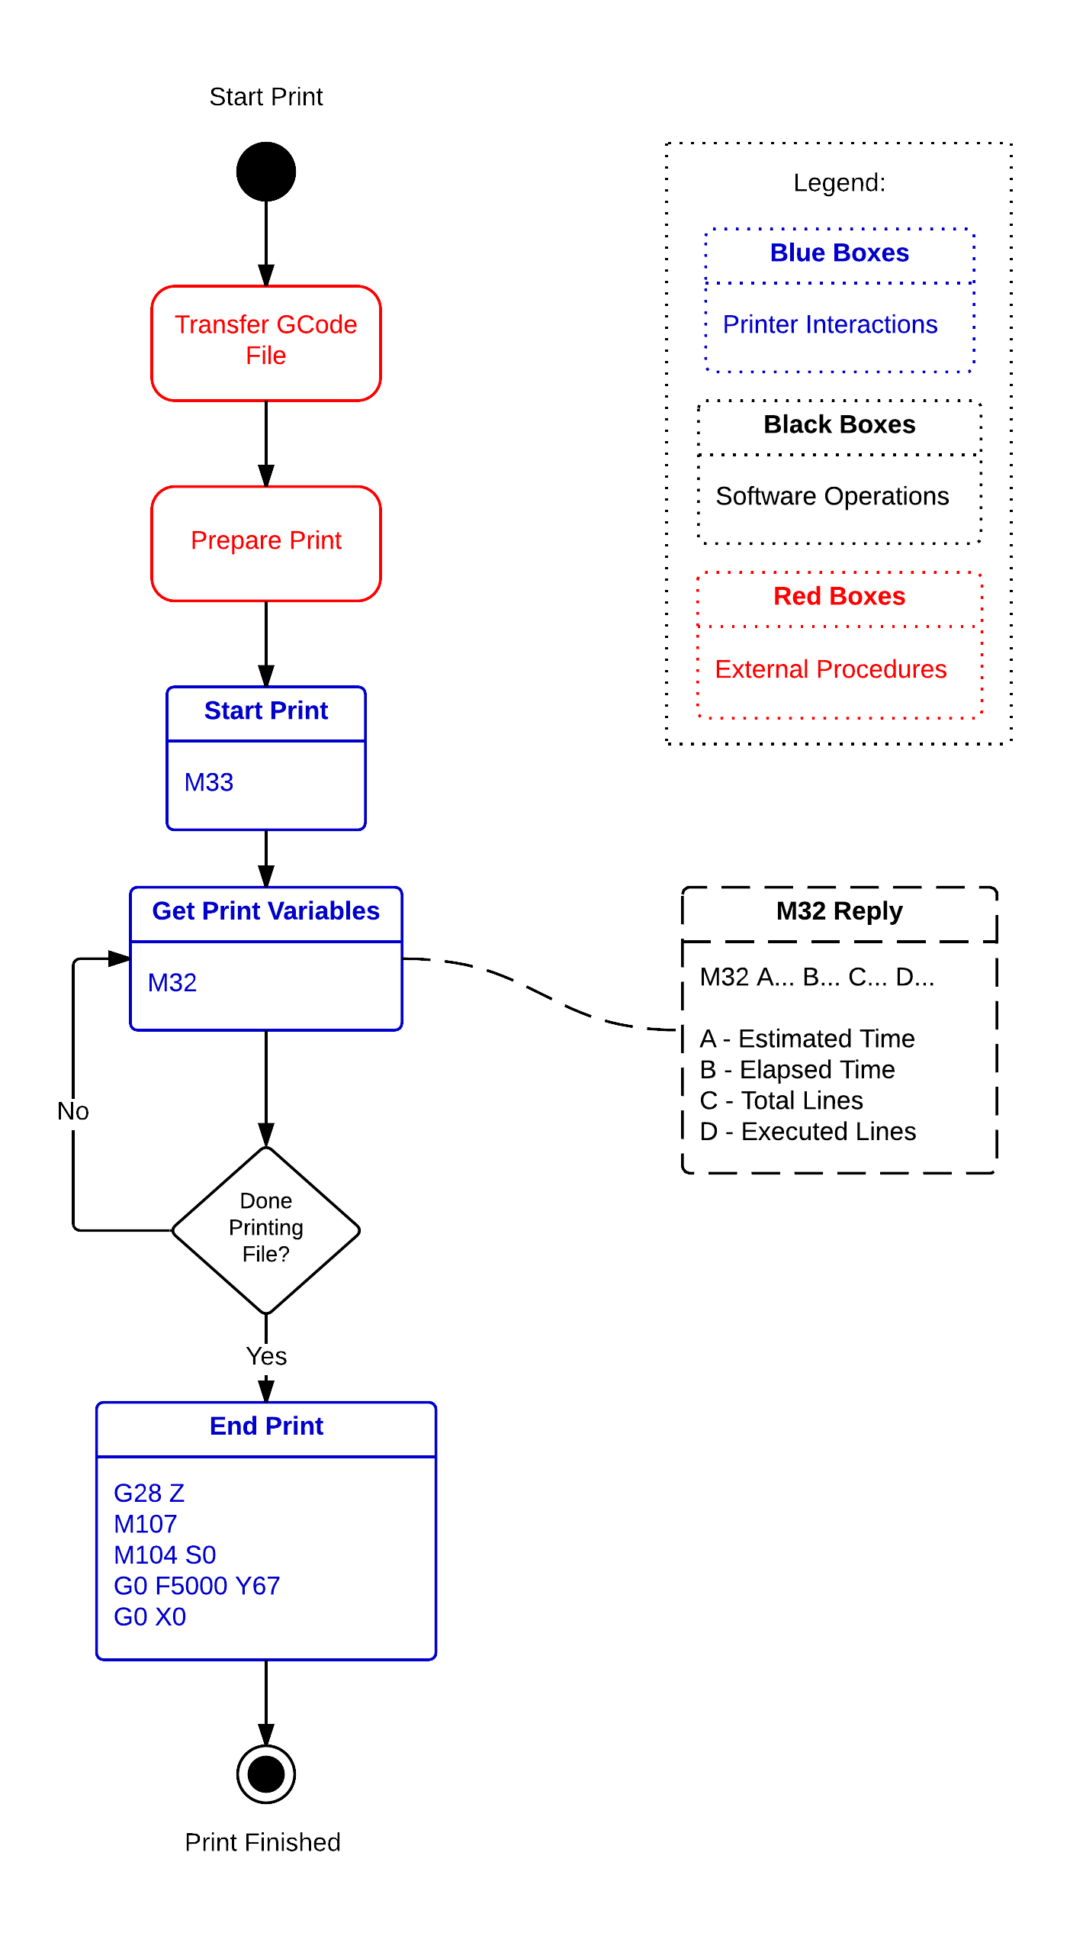

Transfer GCode File

The transfer file is the most important task in the BEETHEFIRST print procedure. The first step is to initialize the internal SD card (M21 command) and create a file. To create a file we must send the command M30 followed by the filename. Filename have the following restrictions:
- Must not have more than 8 characters;
- Can't have special characters;
- Must start with a letter;
- They are not case-sensitive;
- Can't have more than 2 characters after a dot

After creating a file we must transfer the file. Before transferring the GCode to the BEETHEFIRST we must tell it how many bytes we are going to send using the M28 command:
M28 Asss Deee
where:
- sss - is the address of the initial address to write
- eee - is the address of the final address to write

To transfer the file to the printer we can follow 2 approaches:
- Single Block transfer;
- Multi-Block transfer.
In a single block transfer we transfer the total length of the file in a single block. In this approach we send a M28 command with the initial position set to zero and the final position equal to the file size. After sending the M28 command, the printer will only become responsive after receiving the total bytes specified by in the command.
A block is composed of messages with 512 Bytes. These messages must be transferred using a bulk method through the USB connection.
After receiving a M28 command the printer “enters in transfer mode”. The printer will remain in this mode until it receives the total bytes specified in the M28 command arguments. During the transfer mode the printer sends a “tog” response after receiving 512 bytes. We use this method as a flow control mechanism. The software should only send a new 512 byte package after receiving a “tog” from the printer. We forgot to include this detail in our documentation.
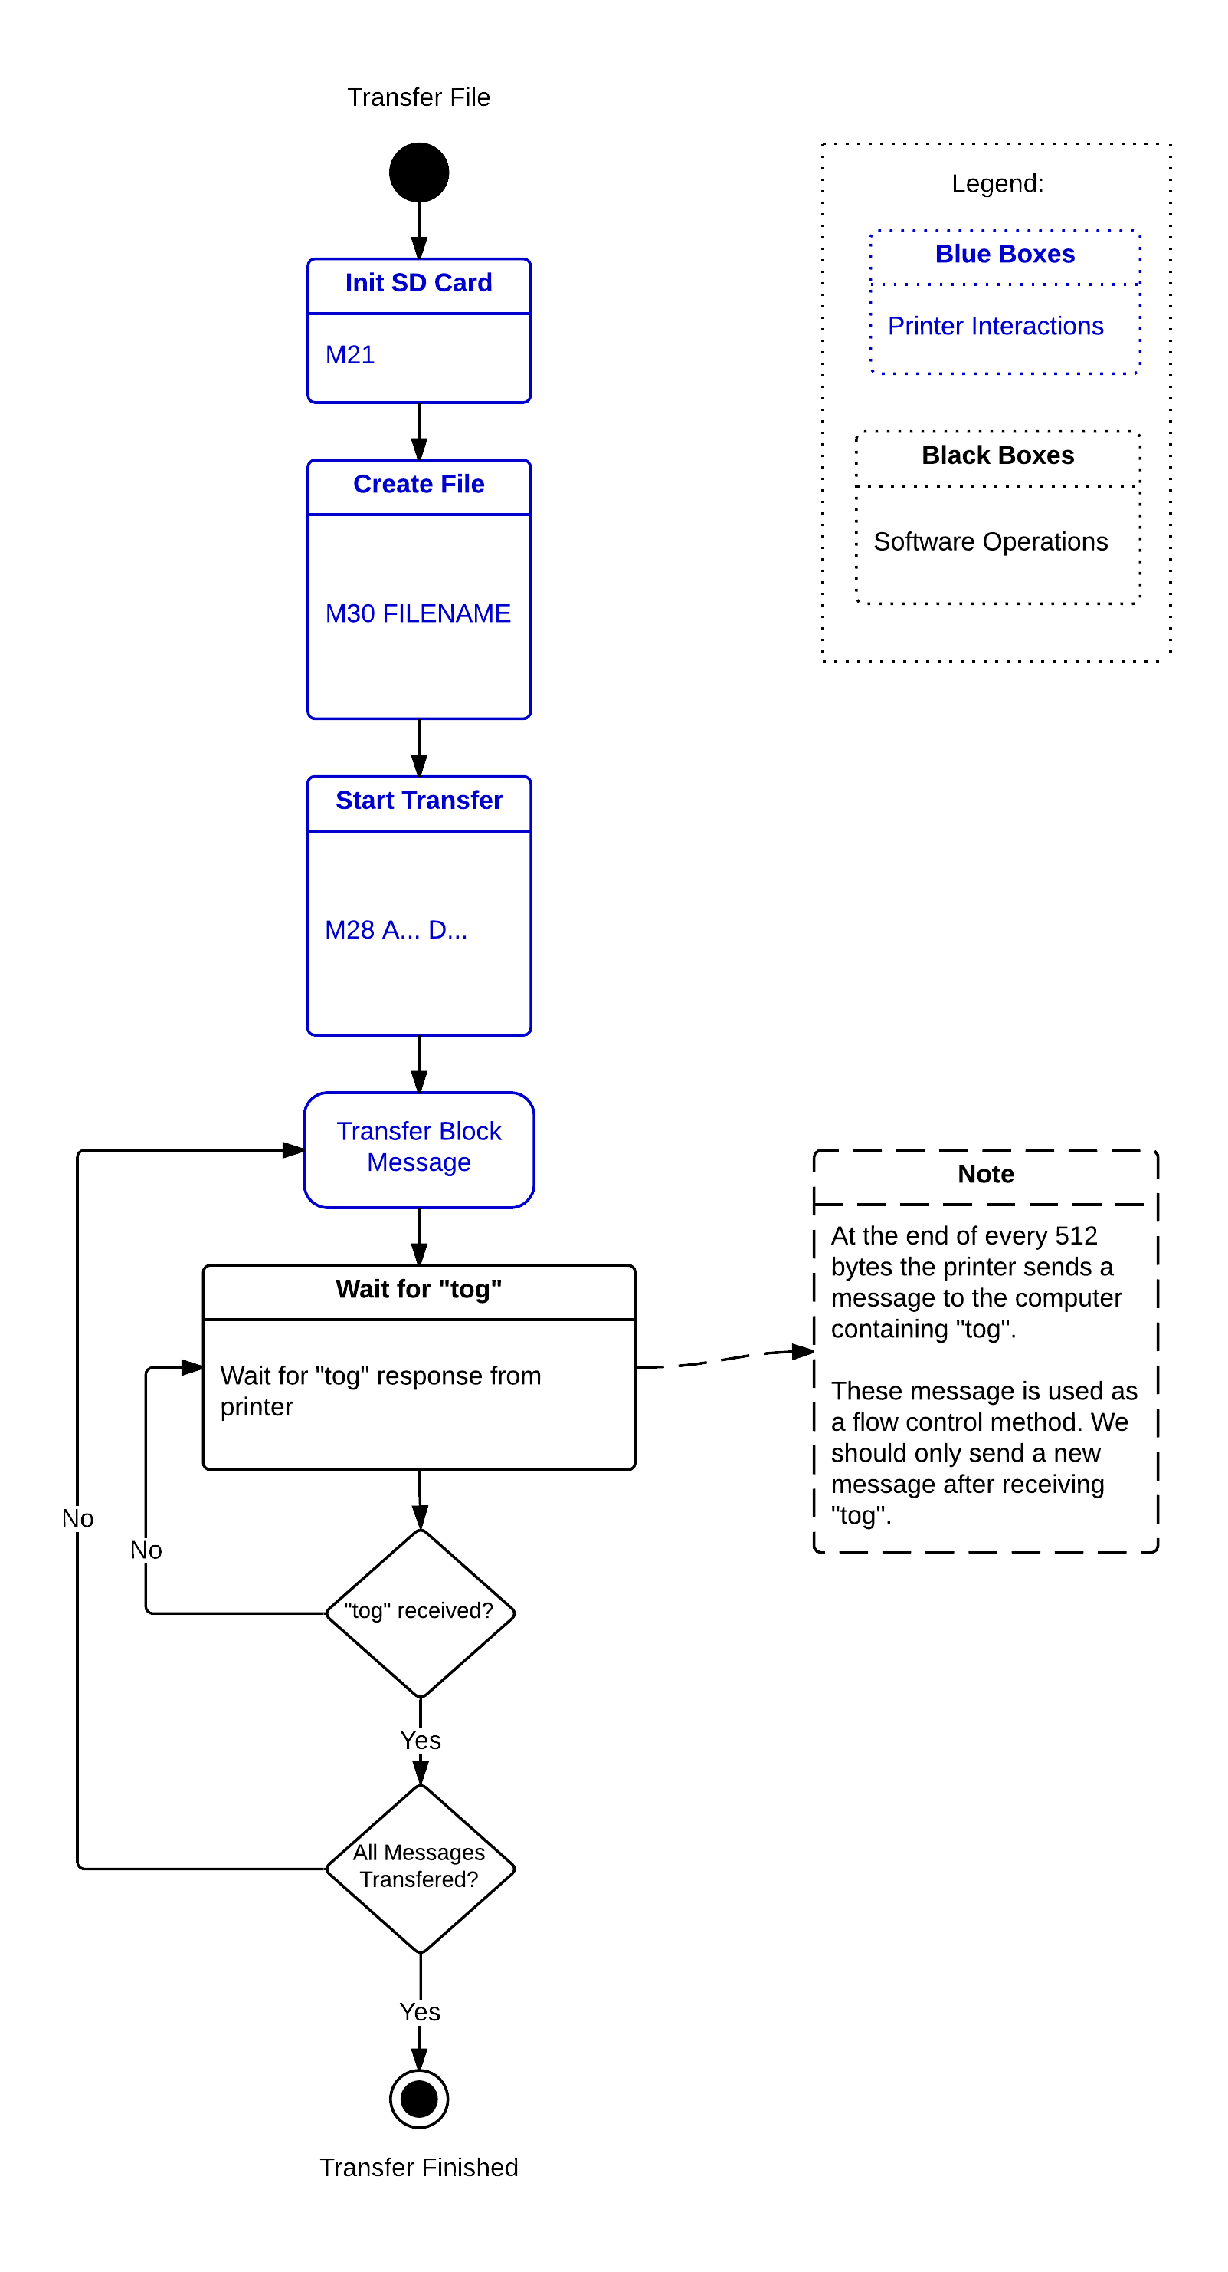
The diagram bellow shows the single block transfer.

The printer becomes inoperational during a file trasnfer. This would inhibit the possiblity of cancelling the transfer or any other action with the printer. For these reason the correct way to transfer a file to the printer is to use a multi-block transfer procedure.
In a Multi-block transfer we devide the file to transfer in different blocks that are transfered to the printer. The trasnfer method for trasnfering a block is similar to the method used to transfer a file using a single block approach.
Note: The printer still becomes irresponsive during a when transferring a block, however we may interact with the printer between a block transfer. This allows us to cancel the transfer and continue operating the printer.
The diagram bellow shows the multi-block transfer implementation:
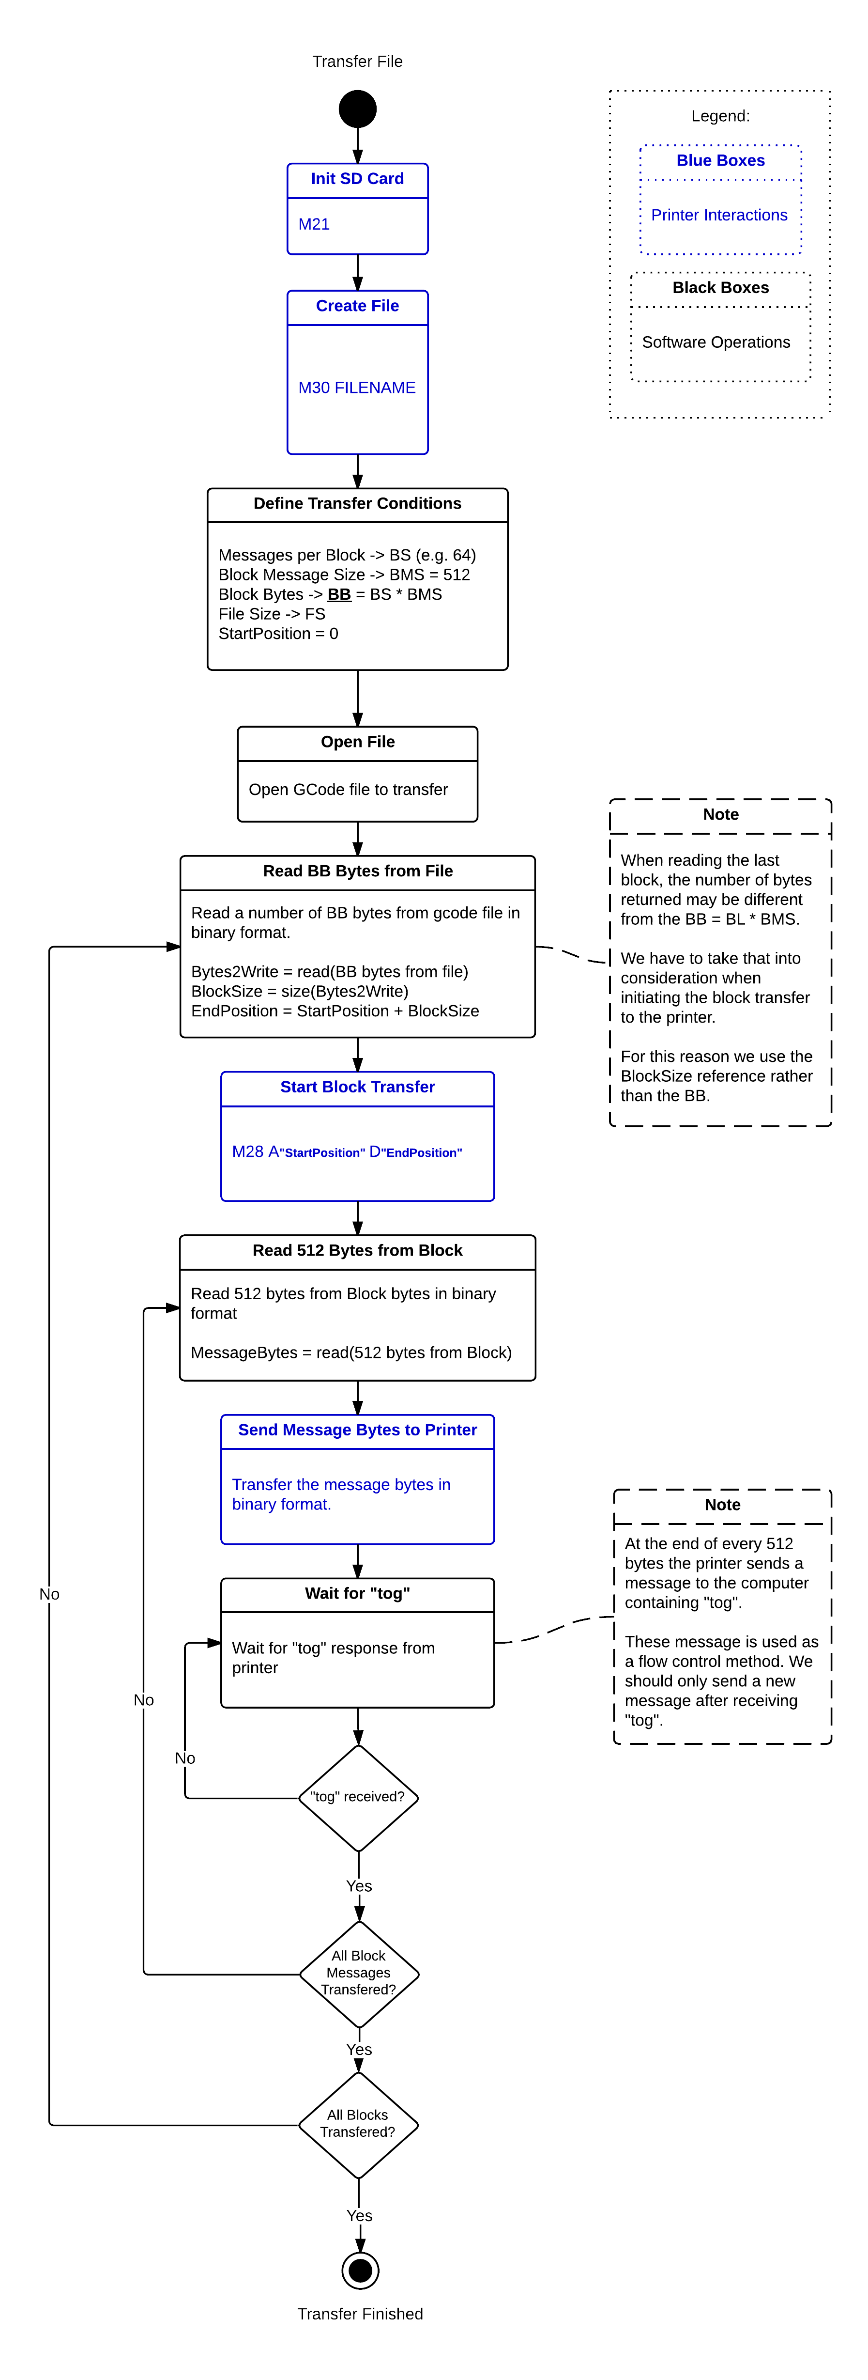

Filament change

The filament change is one of the most frequent operations a user must do when operating a 3D printer. A good filament change procedure will reduce the risk of having nozzle clogs and improve print quality, especially when change between different colors and materials.
The BEETHEFIRST 3D printer and software makes use of its configurations memory to store the code of the filament loaded in the printer. This allows us to create and make use of custom profiles to get the best print quality. The "M400" MCode is used to manage the stored filament code:
- M400 - returns the stored configuration: "bcode:Accc", where ccc is the filament code;
- M400 Accc - Stores a new filament code, where ccc id the filament code.

Below is a diagram that describe the steps to successfully implement this procedure.
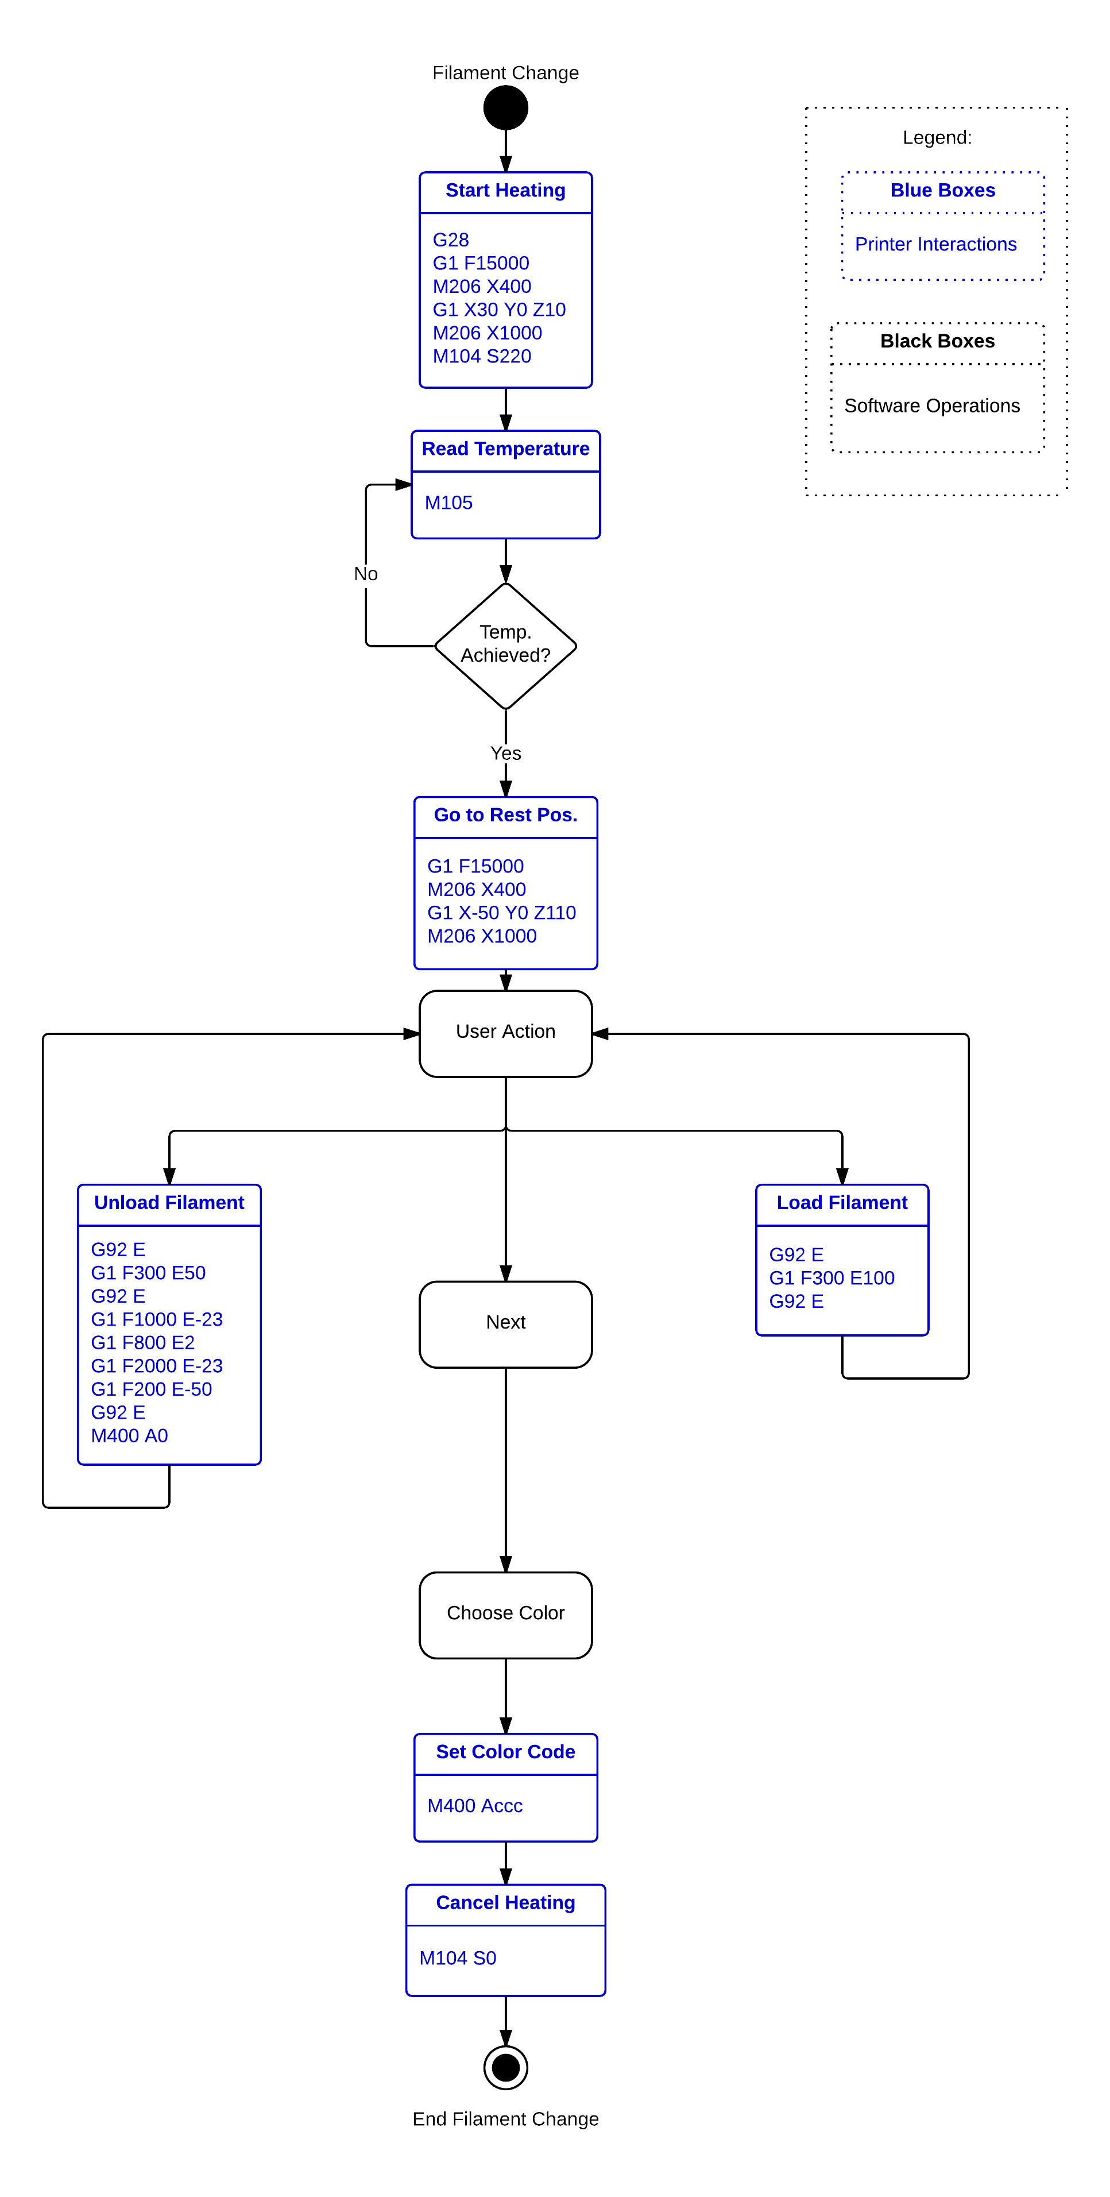

Bed Calibration

The BEESOFT software includes a wizard to guide the user though the printer bed calibration. This allows the user to successfully calibrate the printer by adjusting the height of the bed in three positions.
This procedure starts with the software sending the printer bed to the coordinate X0 Y67 Z2. When in the printer bed arrives at the defined coordinates, the software should provide the user an interface to rise or descend the bed.
After adjusting the first point height the software must send the M603 command followed by a M601 command. The first command defines the new printer height calibration point while the latter stores the position in the config memory so it can be used in new prints.
The second calibration point is located in the position X-31 Y-65 Z0. The software should send a G1 command to the printer and then ask the user to manually adjust the height of the bed by turning the left bolt located under the bed.
Finally, the third calibration point is located in the position X35 Y-65 Z0. The software should send a G1 command to the printer and then ask the user to manually adjust the height of the bed by turning the right bolt located under the bed.
NOTE: The BEETHEFIRST 3D printer operates using absolute coordinates. In order to move the bed up or down the software must follow the following steps:
- Send a M121 command to the printer and retrieve the XYZ coordinates from the response.
- Add or subtract the desires Z step to the Z coordinate
- Send the printer to the new position using a G1 command.

Below is the workflow to calibrate the bed:

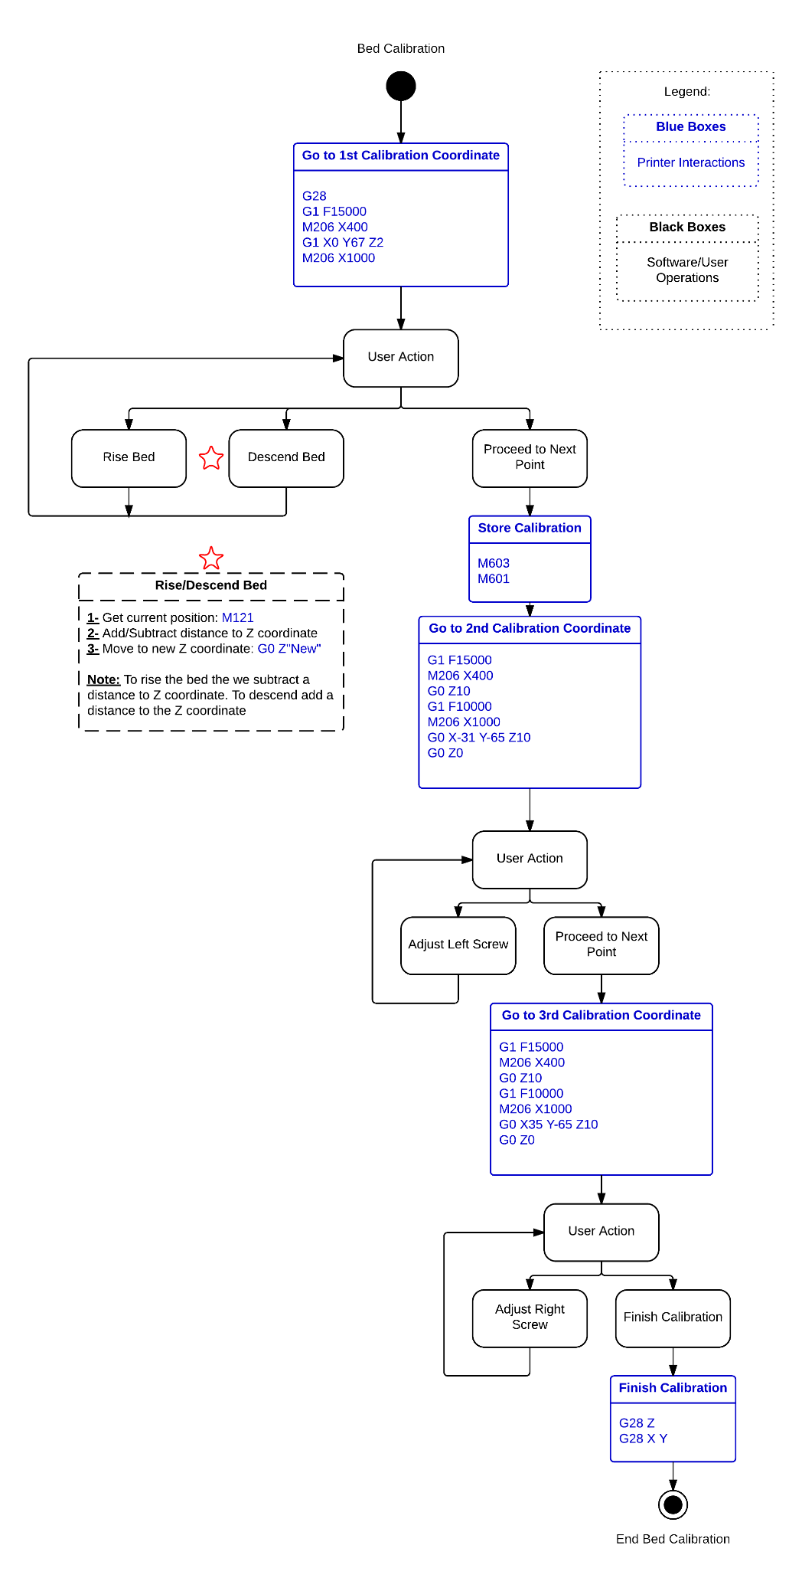
BEETHEFIRST maintenance operations

All text within image is written in copy-pastable form below the image.
Text with yellow background is done so to mimic the look of the same text in the image to allow the reader to better locate it.
Some text in various images has been corrected or improved.

The Maintenance Menu
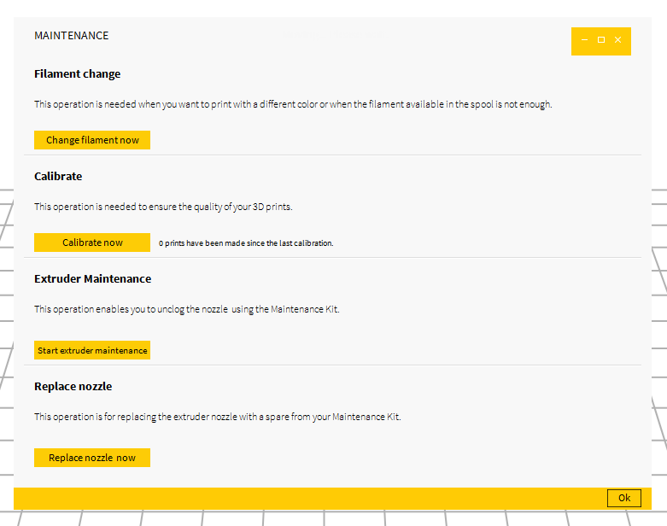

MAINTENANCE
Filament change
This operation is needed when you want to print with a different color or when the filament left in the spool is not enough.
Change filament now

Calibrate
This operation is needed to ensure the quality of your 3D prints.
Calibrate now

Extruder Maintenance
This operation allows you to unclog the nozzle using the Maintenance Kit.
Start extruder maintenance

Replace nozzle
This operation is for replacing the extruder nozzle with a spare from your Maintenance Kit
Replace nozzle now

1. The Filament change function
1.1
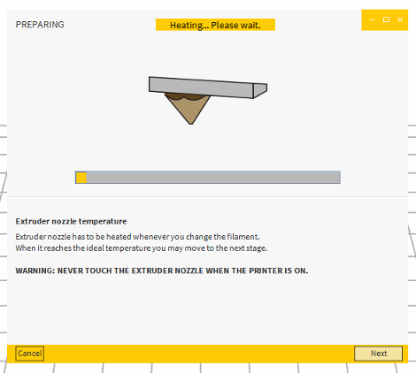

PREPARING
Heating… Please wait.

Extruder nozzle temperature
Extruder nozzle has to be heated whenever you change the filament.
When it reaches the ideal temperature, you may move on to the next stage.
WARNING: NEVER TOUCH THE EXTRUDER NOZZLE WHEN THE PRINTER IS ON

1.2
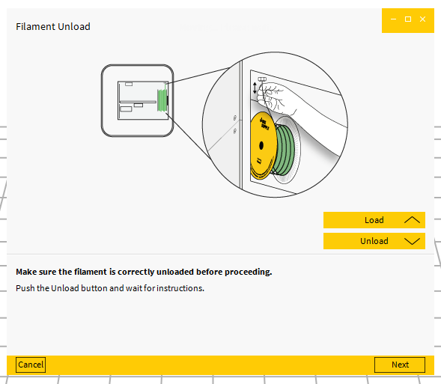

Filament Unload
Moving… Please wait.
Load
Unload
Make sure the filament is correctly unloaded before proceeding.
Push the Unload button and wait for instructions.

1.3 (after loading new filament)
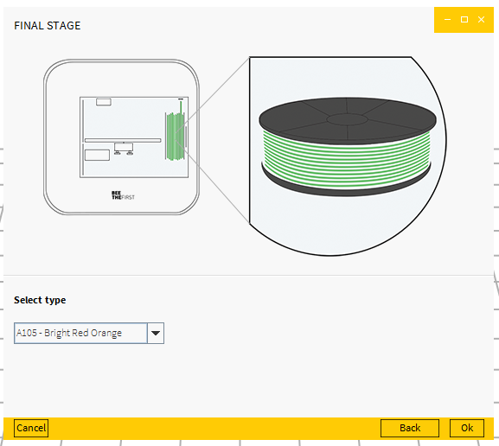
FINAL STAGE
Select type
[Drop list with list of color profiles]

2. Calibration function
2.1
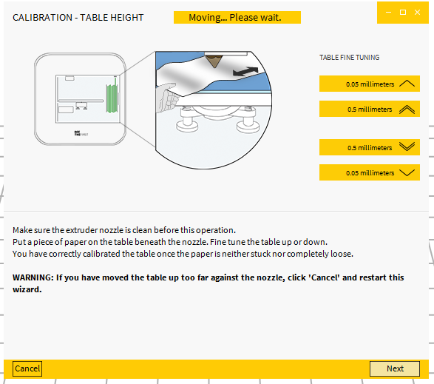
CALIBRATION – TABLE HEIGHT
TABLE FINE TUNING
0.05 millimeters
0.5 millimeters

0.5 millimeters
0.05 millimeters
Make sure the extruder nozzle is clean before this operation.
Put a piece of paper on the table beneath the nozzle. Fine tune the table up or down.
You have correctly calibrated the table once the paper is neither stuck nor completely loose.
WARNING: If you have moved the table up too far against the nozzle, Click ‘Cancel’ and restart this wizard.

2.2
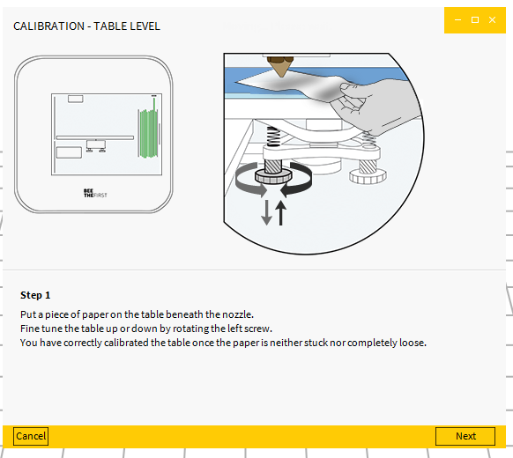
CALIBRATION – TABLE LEVEL
Step 1
Put a piece of paper on the table beneath the nozzle.
Fine tune the table up or down by rotating the left screw.
You have correctly calibrated the table once the paper is neither stuck nor completely loose.

2.3
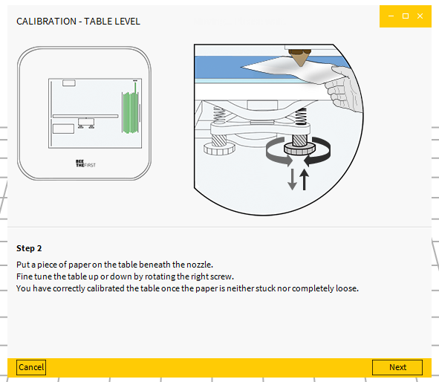
CALIBRATION – TABLE LEVEL
Step 2
Put a piece of paper on the table beneath the nozzle.
Fine tune the table up or down by rotating the right screw.
You have correctly calibrated the table once the paper is neither stuck nor completely loose.

2.4
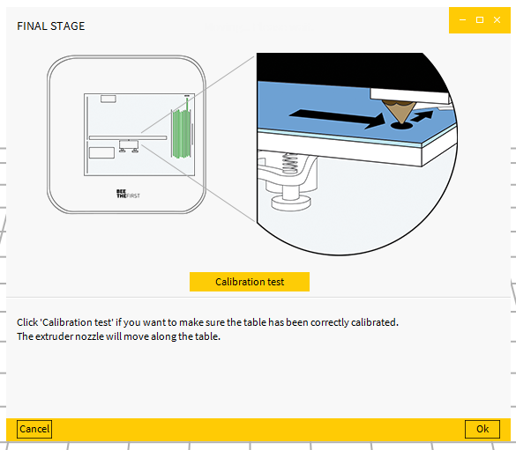
FINAL STAGE
Calibration test
Click ‘Calibration test’ if you want to make sure the table has been correctly calibrated. The extruder nozzle will move along the table.

3. Extruder Maintenance function
3.1
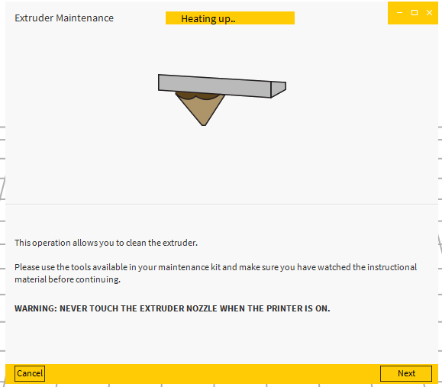
Extruder Maintenance
Heating up…
This operation allows you to clean the extruder.
Please use the tools supplied in your Maintenance Kit and make sure you have watched the instructional material before continuing.
WARNING: NEVER TOUCH THE EXTRUDER NOZZLE WHEN THE PRINTER IS ON
3.2
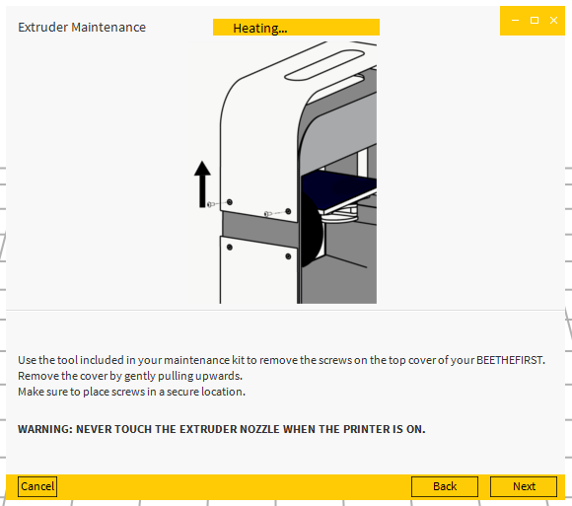
Extruder Maintenance
Heating…
Use the hex key supplied with BEETHEFIRST to remove the screws on the top cover.
Remove the cover by gently pulling upwards.
Make sure you place the screws in a secure location.
WARNING: NEVER TOUCH THE EXTRUDER NOZZLE WHEN THE PRINTER IS ON

3.3
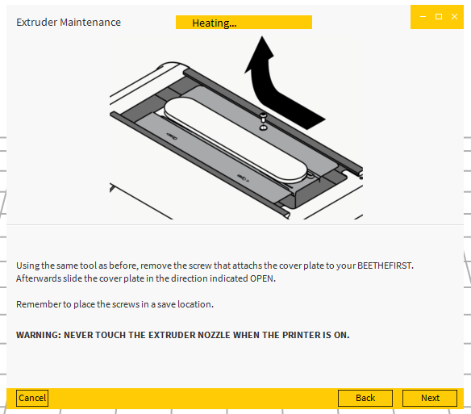
Extruder Maintenance
Heating…
Using the same hex key, remove the screw that holds the cover plate to your BEETHEFIRST. Afterwards, slide the cover plate in the direction indicated by ‘OPEN’.
Remember to place the screw in a safe location.
WARNING: NEVER TOUCH THE EXTRUDER NOZZLE WHEN THE PRINTER IS ON
3.4
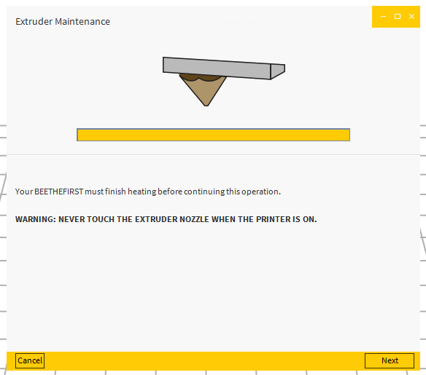
Your BEETHEFIRST must finish heating before continuing this operation.
WARNING: NEVER TOUCH THE EXTRUDER NOZZLE WHEN THE PRINTER IS ON
3.5
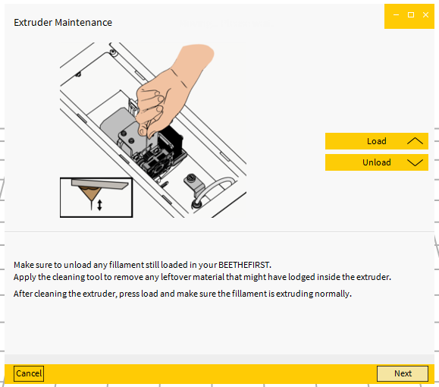

Make sure you unload any filament that may still be in your BEETHEFIRST.
Now apply the cleaning tool provided in the Maintenance Kit as indicated aboe.
Remove any leftover material that might be lodged inside the extruder.
After cleaning the extruder, press ‘Load’ and make sure the filament is extruding normally.
3.6
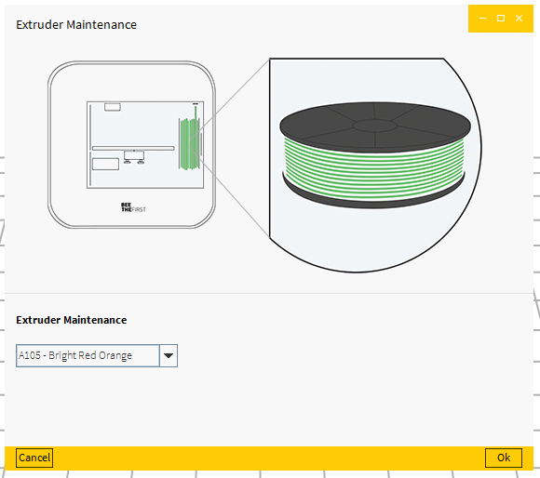

Extruder Maintenance
[Drop list with list of color profiles]

4. Replace nozzle
4.1
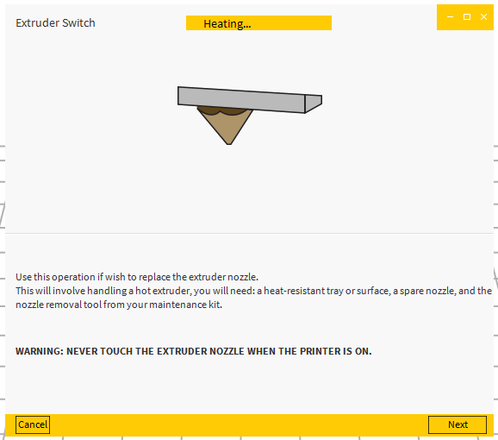
Replace nozzle (instead of ‘Extruder Switch’)
Heating up…
Perform this operation if you wish to replace the extruder nozzle.
This will involve handling a hot extruder. You will need a heat-resistant tray or other surface, a spare nozzle and the nozzle removal tool supplied with your Maintenance Kit.
Please watch the instructional material before continuing.
WARNING: NEVER TOUCH THE EXTRUDER NOZZLE WHEN THE PRINTER IS ON

4.2
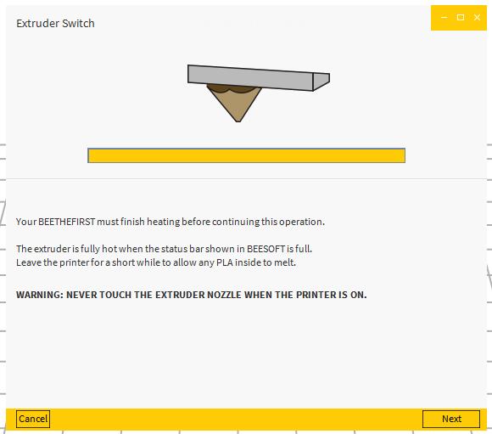

Replace nozzle (instead of ‘Extruder Switch’)
Heating… Please wait.
Your BEETHEFIRST must finish heating before continuing this operation.
The extruder is fully hot when the status bar shown above is full.
Leave the printer for a short while to allow any PLA left inside to melt.
WARNING: NEVER TOUCH THE EXTRUDER NOZZLE WHEN THE PRINTER IS ON

4.3
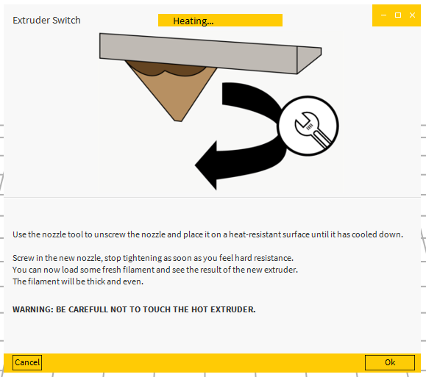
Replace nozzle (instead of ‘Extruder Switch’)
Heating…
Use the nozzle removal tool to unscrew the nozzle.
Place on heat-resistant surface until it has cooled down.
Screw in the new nozzle and stop tightening as soon as you feel hard resistance.
You can now load some fresh filament and see the result of the new extruder.
The filament should be thick and even.
WARNING: NEVER TOUCH THE EXTRUDER NOZZLE WHEN THE PRINTER IS ON
----------------------------------------------------------------------------------------------------------------------------------------------------

BEETHEFIRST USB Descriptor

[14758.724470] usb 3-1.3: New USB device found, idVendor=29c9, idProduct=0001
[14758.724481] usb 3-1.3: New USB device strings: Mfr=1, Product=2, SerialNumber=3
[14758.724488] usb 3-1.3: Product: BEETHEFIRST
[14758.724493] usb 3-1.3: Manufacturer: BEEVERYCREATIVE
[14758.724498] usb 3-1.3: SerialNumber: 0000000001

Here is the LSUSB output on Linux, for the BEETHEFIRST USB descriptor:
Device Descriptor:
bLength 18
bDescriptorType 1
bcdUSB 1.10
bDeviceClass 255 Vendor Specific Class
bDeviceSubClass 0
bDeviceProtocol 0
bMaxPacketSize0 64
idVendor 0x29c9
idProduct 0x0001
bcdDevice 1.00
iManufacturer 1 BEEVERYCREATIVE
iProduct 2 BEETHEFIRST
iSerial 3 0000000001
bNumConfigurations 1
Configuration Descriptor:
bLength 9
bDescriptorType 2
wTotalLength 32
bNumInterfaces 1
bConfigurationValue 1
iConfiguration 0
bmAttributes 0xc0
Self Powered
MaxPower 100mA
Interface Descriptor:
bLength 9
bDescriptorType 4
bInterfaceNumber 0
bAlternateSetting 0
bNumEndpoints 2
bInterfaceClass 255 Vendor Specific Class
bInterfaceSubClass 0
bInterfaceProtocol 0
iInterface 0
Endpoint Descriptor:
bLength 7
bDescriptorType 5
bEndpointAddress 0x05 EP 5 OUT
bmAttributes 2
Transfer Type Bulk
Synch Type None
Usage Type Data
wMaxPacketSize 0x0040 1x 64 bytes
bInterval 0
Endpoint Descriptor:
bLength 7
bDescriptorType 5
bEndpointAddress 0x82 EP 2 IN
bmAttributes 2
Transfer Type Bulk
Synch Type None
Usage Type Data
wMaxPacketSize 0x0040 1x 64 bytes
bInterval 0
Device Status: 0x0000
(Bus Powered)

Gcode Command List
Bootloader/Firmware | Comm. | Arguments | Description
F | G0 | ?X<VAL> ?Y<VAL> ?Z<VAL>  ?F<VAL> | Synchronized movement
F | G1 | ?X<VAL> ?Y<VAL> ?Z<VAL>  ?F<VAL> ?E<VAL> | Synchronized movement
F | G28 | ?X ?Y ?Z ?F ?E | Home Axis
F | G92 | ?X<VAL> ?Y<VAL> ?Z<VAL>  ?F<VAL> ?E<VAL> | Define Current Position
F | M20 | nenhum | list files in root folder
F | M21 | nenhum | init sd card
F | M23 | <file_name> | open file to read
F | M25 | nenhum | pause sd printing
F | M26 | S<position> | Set SD file pos
F | M28 | A<start> D<end> | get transfer size and begin if valid
F | M30 | <file_name> | open file to write
F | M31 | A<estimated time> L<number of lines> | Defione variables of standalone print
F | M32 | nenhum | print variables of standalone
F | M33 | nenhum | start print
F | M104 | S<VAL> | Set extruder temperature (Max 250ºC)
F | M105 | nenhum | Print Extruder Temeprature
F | M106 | nenhum | Turn Blower fan ON
F | M107 | nenhum | Turn Blower fan OFF
F | M109 | S<VAL> | Define extruder setpoiint and block movements
F | M112 | nenhum | Emergency Stop
B | M114 | A<VAL> | Set Firmware Version String
B/F | M115 | nenhum | Print Firmware Version
B | M116 | nenhum | Print Bootloader Version
B/F | M117 | nenhum | Print Serial Number
B | M118 | A<VAL> | Write Serial Number
F | M121 | nenhum | Print Current Position
F | M130 | T<kp> U<Ki> V<kd> | Define PID vars
F | M126 | S<VAL> | Turn Extruder Block ON and Define speed
F | M127 | nenhum | Turn Extruder Block OFF
F | M131 | nenhum | Print Current PID output
F | M134 | nenhum | Turn ON Electronics Fan
F | M135 | nenhum | Turn OFF Electronics Fan
F | M136 | nenhum | Turn LEDs ON
F | M137 | nenhum | Turn LEDs OFF
F | M200 | ?X<VAL> ?Y<VAL> ?Z<VAL>  ?F<VAL> ?E<VAL> | Define steps por mm
F | M206 | ?X<VAL> ?Y ?Z ?F ?E | Define Acceleration
F | M300 | ?S<VAL> ?P<VAL> | Beep
F | M400 | ?A<VAL> | Set BEECODE
F | M600 | nenhum | Print Config Vars
F | M601 | nenhum | Write Current Config Vars to Memory
F | M603 | nenhum | Sets Home Z Pos to the current Z
F | M604 | ?X<VAL> ?Y<VAL> ?Z<VAL> | Define Absolute Home Position
F | M605 | ?X<VAL> ?Y<VAL> ?Z<VAL> | Define RelativeHome Position
F | M607 | nenhum | Reset Config to Default Values
B/F | M609 | nenhum | Reboots Electronics into Bootloader
F | M625 | nenhum | Print Current Printer Status  3: ready  4: moving  5: printing  7: pause  9: shutdown
B | M630 | nenhum | Jump to Firmware
F | M636 | nenhum | Turn ON/OFF Beep every 20s
F | M637 | nenhum | Alive command, DOES NOT GIVE A RESPONSE
F | M638 | nenhum | Print Last N and executed SD Line Number.DO NOT SEND A "N" ARGUMENT
F | M639 | nenhum | echo
F | M640 | nenhum | Waits for queue to clean and pauses print
F | M641 | A<0/1> | Enter/Exit Power saving
F | M642 | W<coeficiente> | Defines FlowRate coefficient
B | M650 | A<VAL> | Sets printer to receive A bytes to firmware
B | M651 | nenhum | Prints Firmware State Variable
B | M652 | A<VAL> | Read Firmware and Config Memory
B | M653 | A<VAL> | Sets printer to receive A bytes to firmware and clears config memory

